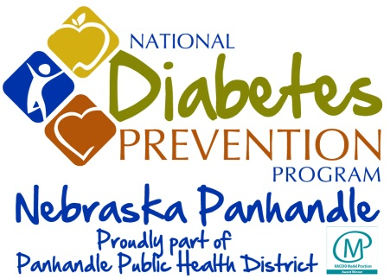
Sharing Your Success…
In Your Own Words

We invite you to share your story with us. Tell us about how your participation in the National Diabetes Prevention Program has positively affected your life and your health. Your story may inspire others to take charge of their health. All stories offer a small but powerful glimpse into what a difference the program has made.

Please tell us about any improvements in your life and your health as a result of your participation.
_____________________________________________________________________________________
_____________________________________________________________________________________
_____________________________________________________________________________________
_____________________________________________________________________________________
_____________________________________________________________________________________
_____________________________________________________________________________________
_____________________________________________________________________________________
_____________________________________________________________________________________
_____________________________________________________________________________________
_____________________________________________________________________________________
_____________________________________________________________________________________
_____________________________________________________________________________________
Thank you for sharing your story and congratulations on your success!

Your story may be an inspiration to others! With your permission we would like to include highlights of
your story in future program materials, presentations and grant submissions.

Do we have your permission to anonymously share your story with others? Yes No

Do we have your permission to use your name if your story is shared? Yes No

Name:___________________________________________________ Community:_______________

